1. Write a NumPy program to create an array of 10 zeros, 10 ones, and 10 fives.

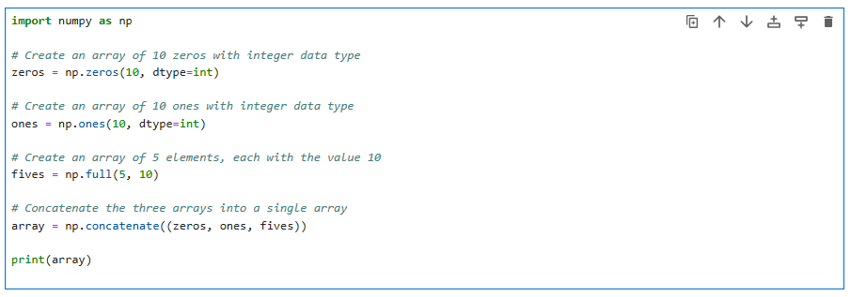

2. Write a NumPy program to create a 3x3 matrix with values ranging from 2 to 10.

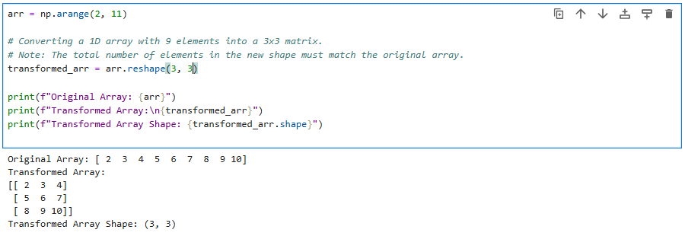

3. Write a NumPy program to create an array with values ranging from 12 to 38.

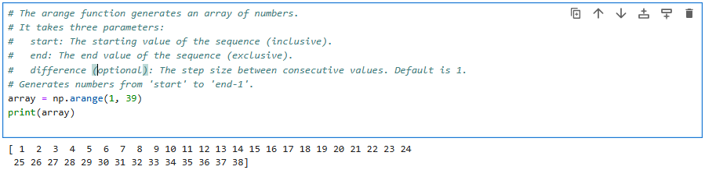

4. Write a NumPy program to convert a list and tuple into arrays.

